Cloud Computing

Assignment 1 – Linux Commands

Name: Pranav Rao

Roll No: 333045

Division: IT-C

Batch: C2

## ls

**Description:** The most frequently used command in Linux to list directories.

# A screenshot of a computer Description automatically generatedOutput:

## Pwd

**Description:** Print working directory command in Linux.

# A screenshot of a computer Description automatically generatedOutput:

## Cd

**Description**: Linux command to navigate through directories.

# A screenshot of a computer Description automatically generated with medium confidenceOutput:

## Mkdir

**Description:** Command used to create directories in Linux

# Text Description automatically generated with medium confidenceOutput:

## mv

**Description:** Move or rename files in Linux.

# Output:

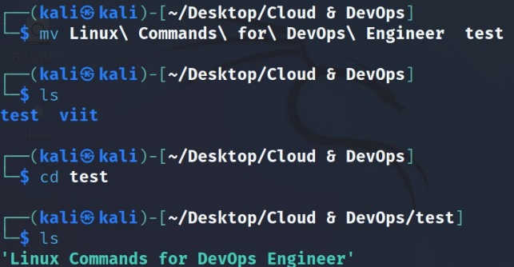

## cp

**Description:** Similar usage as mv but for copying files in Linux

# Text Description automatically generatedOutput:

## rm

**Description:** Delete files or directories

# Text Description automatically generatedOutput:

## touch

**Description:** Create blank/empty files

# Text Description automatically generatedOutput:

## ln

**Description:** Create symbolic links (shortcuts) to other files

# Text Description automatically generatedOutput:

## cat

**Description:** Display file contents on the terminal

# Text Description automatically generatedOutput:

## clear

**Description:** Clear the terminal display

# Text Description automatically generatedOutput:

## echo

**Description:** Print any text that follows the command

# Text Description automatically generatedOutput:

## less

**Description:** Linux command to display paged outputs in the terminal

# Output:

## man

**Description:** Access manual pages for all Linux commands

# Text Description automatically generatedOutput:

## uname

**Description:** Linux command to get basic information about the OS

# Output:

## whoami

**Description:** Get the active username

# Text Description automatically generatedOutput:

## tar

**Description:** Command to extract and compress files in Linux

# Output:

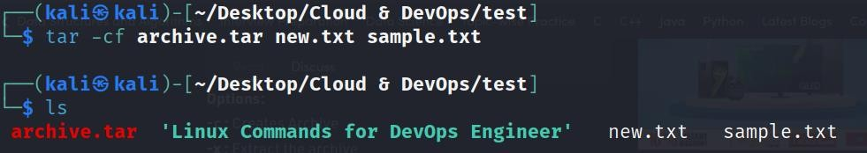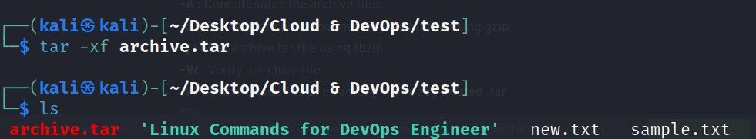

## grep

**Description:** Search for a string within an output

# Text Description automatically generatedOutput:

## head

**Description:** Return the specified number of lines from the top

# Text Description automatically generatedOutput:

## tail

**Description:** Return the specified number of lines from the bottom

# Text Description automatically generatedOutput:

## diff

**Description:** Find the difference between two files

# Text Description automatically generatedOutput:

## cmp

**Description:** Allows you to check if two files are identical

# Text Description automatically generated with low confidenceOutput: $_ means that they are identical

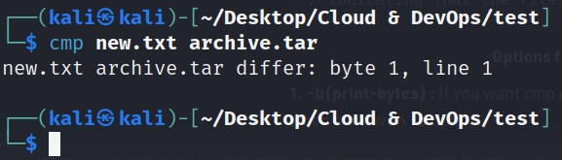

## comm

**Description:** Combines the functionality of diff and cmp

# Text Description automatically generatedOutput:

## sort

**Description:** Linux command to sort the content of a file while outputting

# Text Description automatically generatedOutput:

## export

**Description:** Export environment variables in Linux

# Graphical user interface, text Description automatically generatedOutput:

## zip

**Description:** Zip files in Linux

# Text Description automatically generatedOutput:

## unzip

**Description:** Unzip files in Linux

# Text Description automatically generatedOutput:

## ssh

**Description:** Secure shell command Linux

# Text Description automatically generatedOutput:

## service

**Description:** Linux command to start and stop services

# Text Description automatically generatedOutput:

## ps

**Description:** Display active processes

# Text Description automatically generatedOutput:

## kill/killall

**Description:** Kill active processes by process ID or name

# Output:

## df

**Description:** Display disk filesystem information

# Text Description automatically generatedOutput:

## mount

**Description:** Mount file systems in Linux

# Text Description automatically generatedOutput:

## chmod

**Description:** Command to change file permissions

# Output:

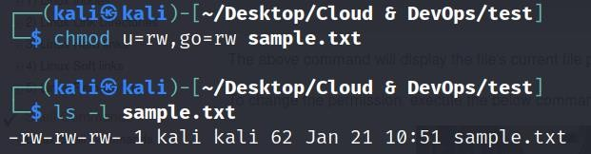

## chown

**Description:** Command for granting ownership of files or folders

# Text Description automatically generatedOutput:

## ifconfig

**Description:** Display network interfaces and IP addresses

# Text Description automatically generatedOutput:

## traceroute

**Description:** Trace all the network hops to reach the destination

# Text Description automatically generatedOutput:

## wget

**Description:** Direct download files from the internet

# Output:

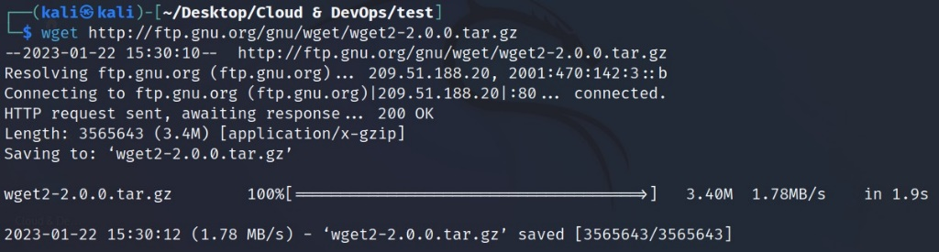

## ufw

**Description:** Firewall command

# Graphical user interface, text Description automatically generatedOutput:

## iptables

**Description:** Base firewall for all other firewall utilities to interface with

# Text Description automatically generatedOutput:

1. apt, pacman, yum, rpm

**Description:** Package managers depending on the distro

# Text Description automatically generatedOutput:

## sudo

**Description:** Command to escalate privileges in Linux

# Text Description automatically generatedOutput:

## cal

**Description:** View a command-line calendar

# A screenshot of a computer Description automatically generated with medium confidenceOutput:

## alias

**Description:** Create custom shortcuts for regularly used commands

# Text Description automatically generatedOutput:

## dd

**Description:** Majorly used for creating bootable USB sticks

# Text Description automatically generatedOutput:

## whereis

**Description:** Locate the binary, source, and manual pages for a command

# Graphical user interface, website Description automatically generatedOutput:

## whatis

**Description:** Find what a command is used for

# Graphical user interface, website Description automatically generatedOutput:

## top

**Description:** View active processes live with their system usage

# Output:

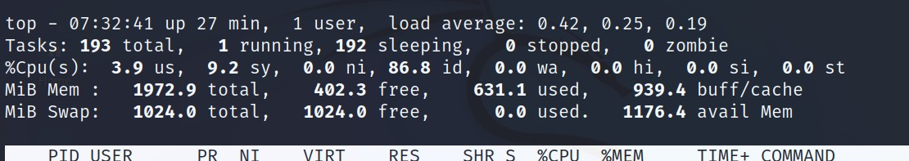

1. useradd and usermod

**Description:** Add new user or change existing users data

# Text Description automatically generatedOutput:

1. passwd

**Description:** Create or update passwords for existing users

# Graphical user interface, text Description automatically generatedOutput:

1. ls -1 | wc -l

**Description:** Command to get the count of the files present into directory.

# Graphical user interface, text Description automatically generatedOutput:

## Kill-

**Description:** Command to kill the process (PID)

# Graphical user interface, text Description automatically generatedOutput:

## W

**Description:** to check how many users logged into the linux

# Output:

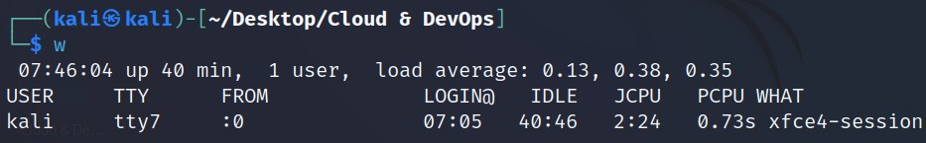

1. Date

**Description:** used to check the current date, time in linux

# Graphical user interface, text Description automatically generatedOutput:

## Ls-a

**Description:** List the hidden files in directory (hidden files are denoted as ..)

# Text Description automatically generatedOutput:

## Ls-l

**Description:** Use to check the permissions on all the files

# Text Description automatically generatedOutput:

## Ls-r

**Description:** used to list information about files and directories within the file system.

# Text Description automatically generatedOutput:

## Rm--rf

**Description:** remove directory with the files

# Text Description automatically generatedOutput: